VRAM Memory Fragmentation Issue
To resolve VRAM memory fragmentation issue, the maximum buffer required for the runtime merge widget (Animation = True, Clip = Disable) should be configured in Clip Area settings. Only width and height has to be configured, no need to give x and y. Find below the GDT snapshot:

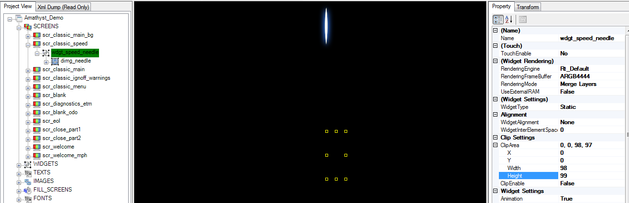

Based on the maximum width and height given in Clip Area settings, initial VRAM buffer will be created for the widget. VRAM buffer will be allocated again only if the new width and height of runtime widget is greater than the maximum width and height mentioned in Clip Area settings. Otherwise same VRAM buffer will be used and this avoids the VRAM memory fragmentation issue.
For example, BAIC program uses the needle of size 40*100. For this maximum size of buffer required in the entire rotation from 0 to 240 is 98*99. This has to be mentioned in the Clip Area settings of wdgt_speed_needle even though Clip is disabled.
For the above example, if we don’t know how much to allocate buffer size, better to give the maximum size of 100*100 in wdgt_speed_needle.
If Clip Area width and height is not mentioned, then GFX Manager will calculate the width and height in runtime and store the maximum width and height. But before GFX manager finds out the maximum width and height, lot of allocation and deallocation of VRAM buffer could have happened. So it’s better to mention the maximum width and height in Clip Area settings to avoid VRAM fragmentation issue.

